1. **Contacts:**

**NCAR/EOL Processing and Quality Control:**

Scot Loehrer (NCAR/EOL)

[loehrer@ucar.edu](mailto:loehrer@ucar.edu)

**Original Data Source:**

NOAA/NCDC

1. **Dataset Overview**

The National Weather Service (NWS) routinely releases radiosondes at 00 and 12 UTC with occasional special releases at sites throughout the United States. This data set includes the quality controlled TCI NWS soundings released at sites near the locations of TCI flown tropical cyclones. TCI flew two storms in the Atlantic (Erika and Joaquin) and two storms in the eastern Pacific basin (Marty and Patricia). For Erika this data set includes soundings from 25-30 August 2015 from Key West, Miami, Tampa Bay, and San Juan (Figure 1). For Joaquin the included soundings are from 25 September to 6 October 2015 from Albuquerque, Albany, Birmingham, Amarillo, Brownsville, Buffalo, Caribou, Chatham, Corpus Christi, Del Rio, Greensboro, Fort Worth, Gray, Sterling, Lake Charles, Wilmington, Lincoln, Jackson, Slidell, Little Rock, Midland, Nashville, Norman, Pittsburgh, Blacksburg, Shreveport, Key West, Miami, Jacksonville, Charleston, Tampa Bay, Tallahassee, Newport, Upton, and San Juan (Figure 2). For Patricia the included soundings are from 19-24 October 2015 from Brownsville and Corpus Christi (Figure 3). Marty was not near any NWS sounding locations. A total of 1059 quality-controlled, high vertical resolution (1-second) soundings are contained in the final TCI data set.

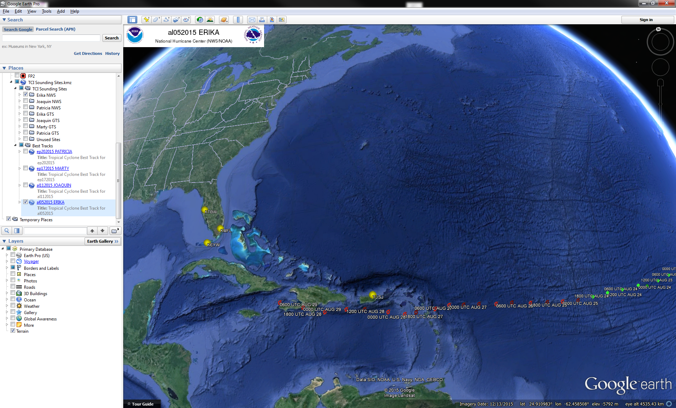

Figure 1. Tropical Storm Erika best track and NWS sounding locations.

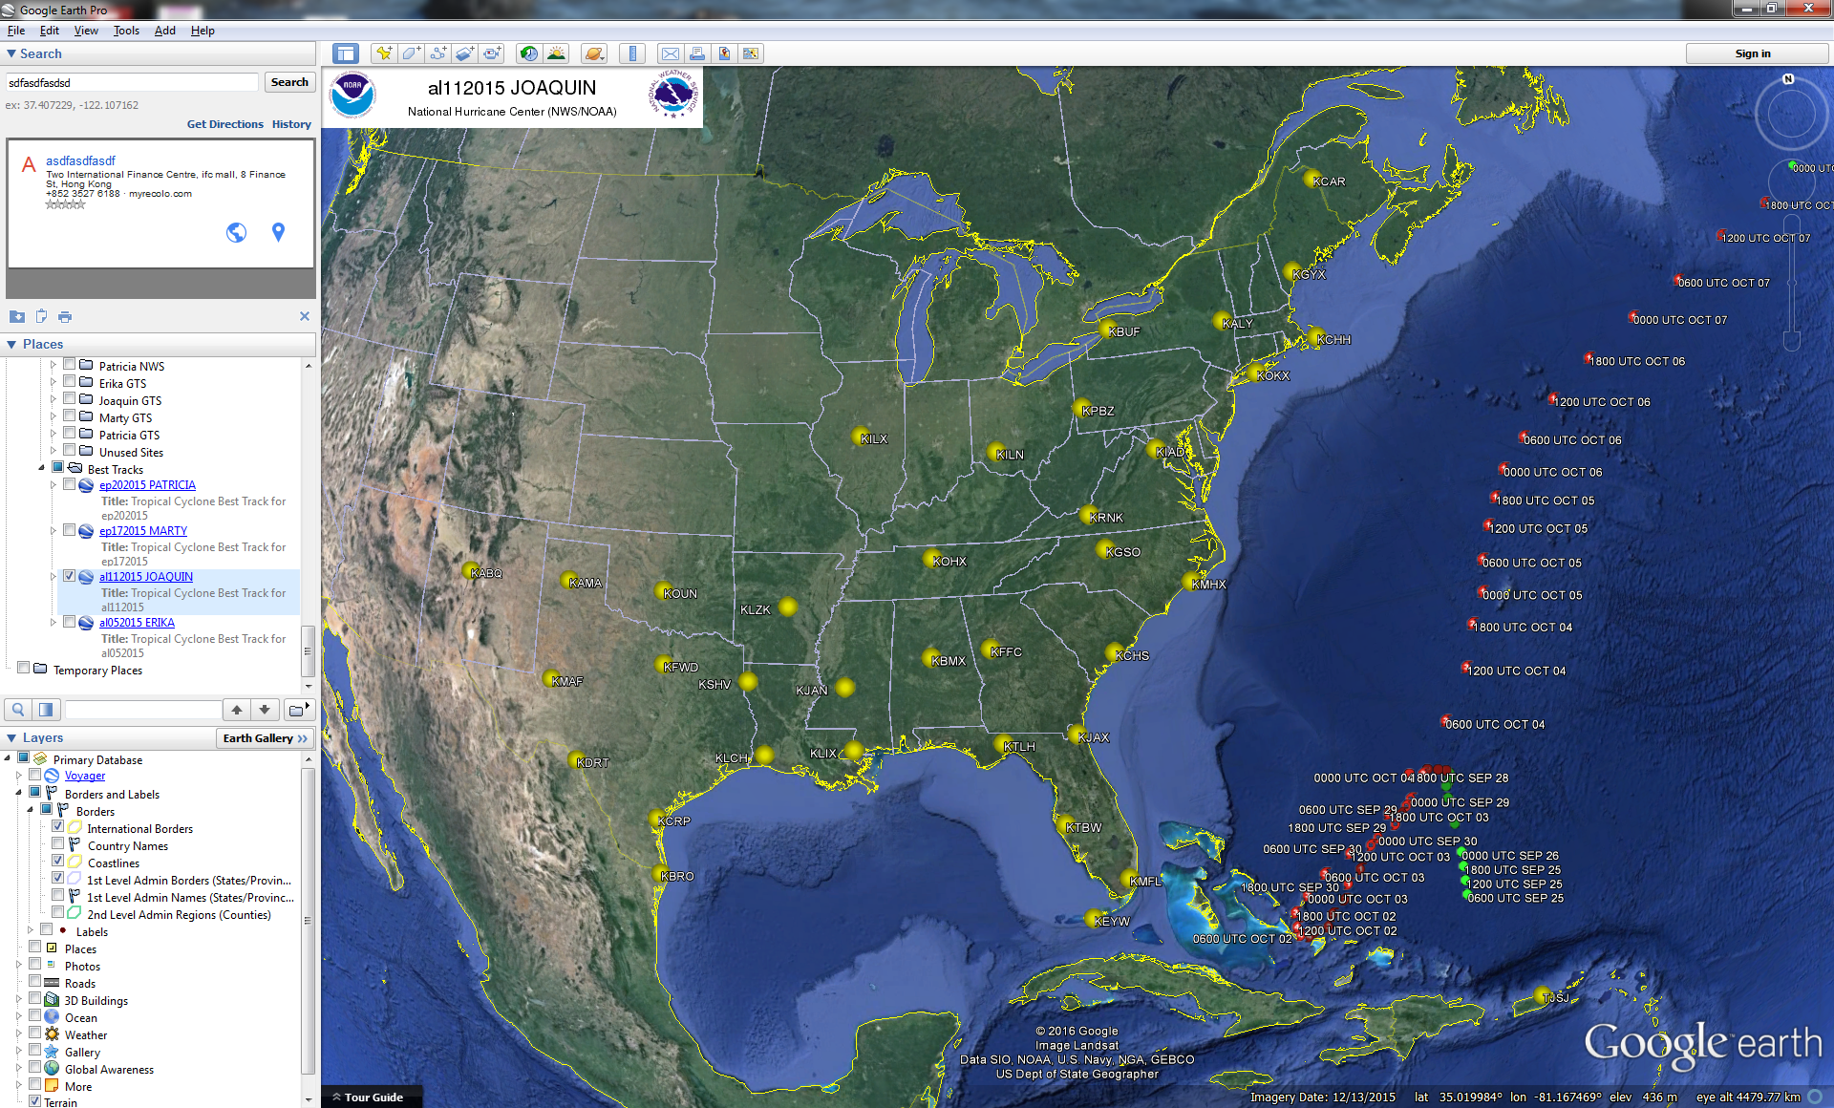

Figure 2. Hurricane Joaquin best track and NWS sounding locations.

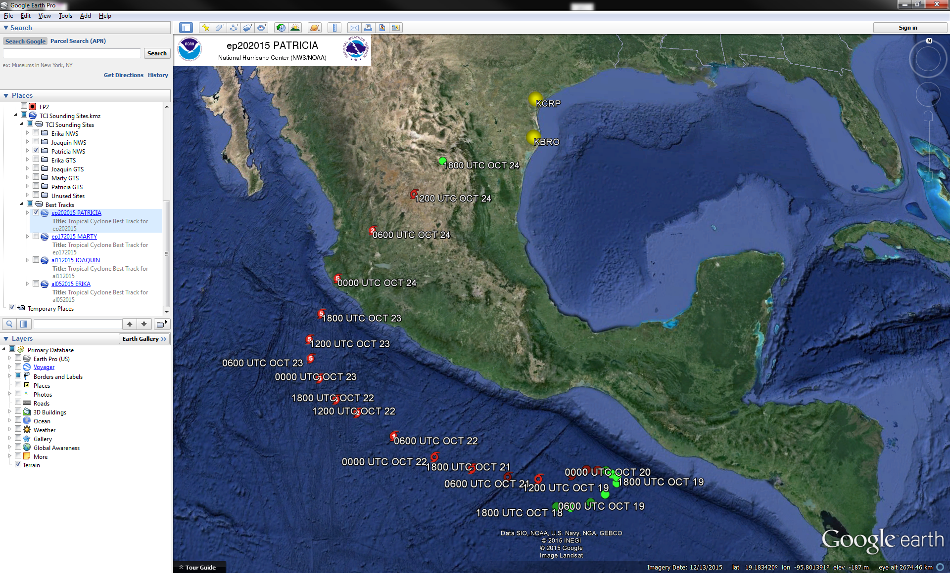

Figure 3. Hurricane Patricia best track and NWS sounding locations.

1. **Project Overview**

The goal of the Tropical Cyclone Intensity (TCI) initiative was to improve the prediction of tropical cyclone intensity and structure changes with a specific focus on an improved understanding of tropical cyclone upper-level outflow layer processes and dynamics. The primary TCI observations were taken by the NASA WB-57 aircraft and the High Definition Sounding System (HDSS) dropsondes and Hurricane Imaging Radiometer (HIRAD). TCI worked closely with the NOAA SHOUT (Sensing Hazards with Operational Unmanned Technology) project which utilized a NASA Global Hawk. TCI also partnered with the routine operations of the USAF C-130, NOAA P-3, and NOAA G-IV aircraft.

1. **EOL File Format Description**

The EOL format is an ASCII text format that includes a header (Table 1), with detailed project and sounding information, and seventeen columns of high resolution data (Table 2).

The header contains information including data type, project name, site location, actual release time, and other specialized information. The first seven header lines contain information identifying the sounding. The release location is given as: lon (deg min), lon (dec. deg), lat (deg min), lat (dec. deg), altitude (meters). Longitude in deg min is in the format: ddd mm.mm'W where ddd is the number of degrees from True North (with leading zeros if necessary), mm.mm is the decimal number of minutes, and W represents W or E for west or east longitude, respectively. Latitude has the same format as longitude, except there are only two digits for degrees and N or S for north/south latitude. The following three header lines contain information about the data system and auxiliary information and comments about the sounding. The last 3 header lines contain header information for the data columns. Line 12 holds the field names, line 13 the field units, and line 14 contains dashes (--- characters) signifying the end of the header. Data fields are listed below in Table 2.

The files contain data calculated at one-second intervals. We have utilized the processed PTU and GPS data from the Radiosonde Replacement System (RRS) sounding systems to generate these files. The raw position, temperature and RH data are normalized by linear interpolation into 1 second processed data. The raw pressure data are normalized by least square interpolation into 1 second processed data. The pressure data are smoothed over 11 seconds of corrected pressure and the result is applied to the 6th corrected pressure within the 11 second spread. The temperature data are smoothed over 9 seconds of uncorrected temperature and the result is applied to the 5th uncorrected temperature within the 9 second spread. There must be at least 2 good raw temperature elements with the 9 second spread.

The following corrections were applied by the RRS sounding system.

Pressure correction - pressure correction is used to compensate for offsets of the radiosonde pressure sensor as compared to the station's pressure sensor. The pressure offset is determined during the radiosonde baseline operations. The correction is applied to the uncorrected pressure prior to pressure

smoothing.

This correction is defined as:

Pc = Pu * (Pstn/Psonde)

where Pc is the corrected pressure

Pu is the uncorrected pressure

Pstn is the station pressure

Psonde is the radiosonde surface pressure

Temperature correction - temperature correction is used to compensate for

solar radiation. The correction is applied to the smoothed temperature.

These corrections are proprietary to Sippican.

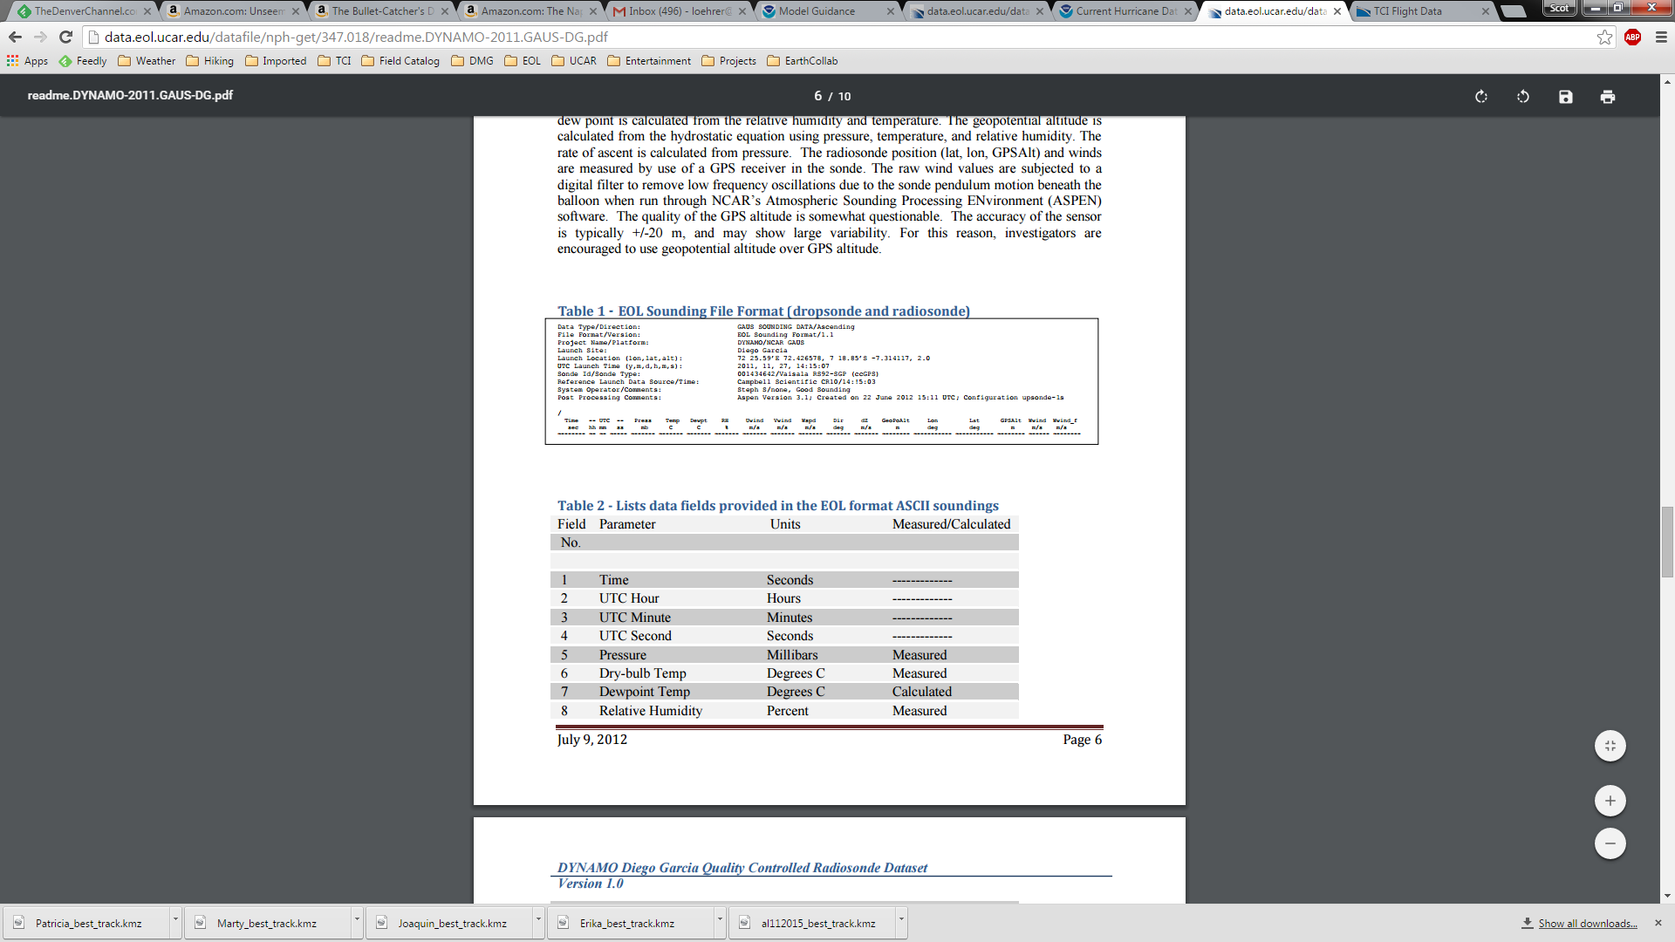

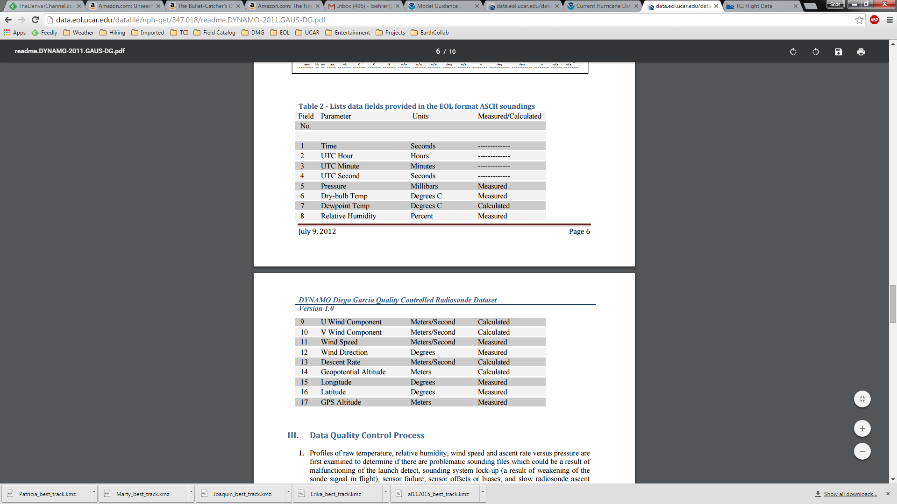



**4.1 Data Specifics**

The files contain data at one-second intervals.

The file naming convention is XXXX_DYYYYMMDD_HHmmSS_P.1.eol

Where XXXX is the Site ID, D is the letter D, YYYY is the year, MM is the month, DD is the day of the month, HH is the hour, mm the minute and SS the seconds. All times are UTC.

Vaisala RS92-NGP radiosondes were used by KBRO, KCAR, KCRP, KGXY, KJAX, KKEY, KLCH, KLIX, KMFL, KMHX, KOKX, and TJSJ.

Lockheed Martin Sippican LMS-6 radiosondes were used by KABQ, KALY, KAMA, KBMX, KBUF, KCHH, KCHS, KDRT, KFFC, KFWD, KGSO, KIAD, KILN, KILX, KJAN, KLZK, KMAF, KOHX, KOUN, KPBZ, KRNK, KSHV, KTAE, and KTBW.

All sounding sites used GPS for windfinding.

**4.2 Sample Data**

The following is a sample of the TCI NWS high resolution radiosonde data in EOL format.

Data Type/Direction: National Weather Service Sounding/Ascending

File Format/Version: EOL Sounding Format/1.1

Project Name/Platform: TCI

Launch Site: KTBW Tampa Bay, FL / 72210

Launch Location (lon,lat,alt): 082 24.08'W -82.401000, 27 42.32'N 27.705000, 13.00

UTC Launch Time (y,m,d,h,m,s): 2015, 08, 24, 23:02:11

Sonde Id/Sonde Type: 88084424/Lockheed Martin Sippican LMS-6 GPS Radiosonde

Reference Launch Data Source/Time:

System Operator/Comments:

Post Processing/Comments:

/

Time -- UTC -- Press Temp Dewpt RH Uwind Vwind Wspd Dir dZ GeoPoAlt Lon Lat GPSAlt

sec hh mm ss mb C C % m/s m/s m/s deg m/s m deg deg m

-------- -- -- ----- ------- ------- ------- ------- ------- ------- ------- ------- ------- -------- ----------- ----------- --------

-1.00 23 2 11.00 1010.40 30.50 24.90 72.00 1.90 -0.70 2.00 290.20 -999.00 13.00 -82.401000 27.705000 -999.00

0.00 23 2 12.00 1009.70 30.50 24.20 69.30 1.80 -0.60 1.90 288.40 6.00 19.00 -82.401000 27.705000 -999.00

1.00 23 2 13.00 1009.10 30.30 23.90 68.60 1.70 -0.50 1.80 286.40 6.00 25.00 -82.401000 27.705000 -999.00

**4.3 Station List**

|  |  |  |  |  |  |  |
| --- | --- | --- | --- | --- | --- | --- |
| **Site ID** | **WMO ID** | **Site Name** | **State** | **Latitude** | **Longitude** | **Elev (m)** |
| KABQ | 72365 | Albuquerque | NM | 35.038 | -106.623 | 1619 |
| KALY | 72518 | Albany | NY | 42.692 | -73.833 | 95 |
| KAMA | 72363 | Amarillo | TX | 35.233 | -101.709 | 1095 |
| KBMX | 72230 | Birmingham | AL | 33.180 | -86.783 | 174 |
| KBRO | 72250 | Brownsville | TX | 25.916 | -97.420 | 7 |
| KBUF | 72528 | Buffalo | NY | 42.940 | -78.725 | 218 |
| KCAR | 72712 | Caribou | ME | 46.868 | -68.014 | 191 |
| KCHH | 74494 | Chatham | MA | 41.657 | -69.959 | 15 |
| KCHS | 72208 | Charleston | SC | 32.895 | -80.028 | 13 |
| KCRP | 72251 | Corpus Christi | TX | 27.779 | -97.505 | 15 |
| KDRT | 72261 | Del Rio | TX | 29.375 | -100.918 | 314 |
| KFFC | 72215 | Peachtree City | GA | 33.356 | -84.567 | 245 |
| KFWD | 72249 | Fort Worth | TX | 32.835 | -97.298 | 195 |
| KGSO | 72317 | Greensboro | NC | 36.098 | -79.943 | 276 |
| KGYX | 74389 | Gray | ME | 43.893 | -70.257 | 124 |
| KIAD | 72403 | Sterling | VA | 38.977 | -77.486 | 88 |
| KILN | 72426 | Wilmington | OH | 39.421 | -83.821 | 323 |
| KILX | 74560 | Lincoln | IL | 40.151 | -89.338 | 179 |
| KJAN | 72235 | Jackson | MS | 32.320 | -90.080 | 91 |
| KJAX | 72206 | Jacksonville | FL | 30.483 | -81.701 | 10 |
| KKEY | 72201 | Key West | FL | 24.553 | -81.789 | 13 |
| KLCH | 72240 | Lake Charles | LA | 30.126 | -93.217 | 5 |
| KLIX | 72233 | Slidell | LA | 30.338 | -89.825 | 10 |
| KLZK | 72340 | Little Rock | AR | 34.836 | -92.260 | 173 |
| KMAF | 72265 | Midland | TX | 31.943 | -102.190 | 874 |
| KMFL | 72202 | Miami | FL | 25.756 | -80.384 | 4 |
| KMHX | 72305 | Newport | NC | 34.776 | -76.878 | 11 |
| KOHX | 72327 | Nashville | TN | 36.247 | -86.562 | 180 |
| KOKX | 72501 | Upton | NY | 40.865 | -72.863 | 20 |
| KOUN | 72357 | Norman | OK | 35.181 | -97.438 | 345 |
| KPBZ | 72520 | Pittsburgh | PA | 40.532 | -80.218 | 360 |
| KRNK | 72318 | Blacksburg | VA | 37.206 | -80.414 | 639 |
| KSHV | 72248 | Shreveport | LA | 32.452 | -93.842 | 85 |
| KTAE | 72214 | Tallahassee | FL | 30.446 | -84.300 | 53 |
| KTBW | 72210 | Tampa Bay | FL | 27.705 | -82.401 | 13 |
| TJSJ | 78526 | San Juan | PR | 18.431 | -65.992 | 3 |

**5.0 Data Quality Control Procedures**

1. Each sounding was converted from its original format into the ESC format described above.
2. Each sounding was passed through a set of automated data quality checks which included basic gross limit checks as well as rate of change checks. This is further described in Section 4.1.
3. Each sounding was visually examined utilizing the NCAR/EOL XQC sounding quality control software. This is further described in Section 4.2.

**5.1 Automated Data Quality Checks**

This data set was passed through a set of automated data quality checks. This procedure includes both gross limit checks on all parameters as well as rate-of-change checks on temperature, pressure, and ascent rate. A version of these checks is described in Loehrer et al. (1996) and Loehrer et al. (1998).

**5.1.1 Gross Limit Checks**

These checks were conducted on each sounding and the data quality flags in the ESC files were adjusted as appropriate. Only the data point under examination was flagged. All checks also produced warning messages that specified the location of the problem and the severity of the issue. These warning messages where then summarized statistically and examined to determine any consistent issues.

For this data set NCAR/EOL conducted the following gross limit checks. In the table P = pressure, T = temperature, RH = relative humidity, U = U wind component, V = V wind component, B= bad, and Q = questionable.

|  |  |  |  |
| --- | --- | --- | --- |
| **Parameter** | **Check** | **Parameter(s) Flagged** | **Flag Applied** |
| Pressure | <0 or > 1050 | P | B |
| Altitude | < 0 or >40000 | P, T, RH | Q |
| Temperature | < -90 or > 45 | T | B |
| Dew Point | < -99.9 or > 33  > T | RH  T, RH | Q  Q |
| Wind Speed | < 0 or > 100  > 150 | U, V  U, V | Q  B |
| U Wind | < 0 or > 100  > 150 | U  U | Q  B |
| V Wind | < 0 or > 100  > 150 | V  V | Q  B |
| Wind Direction | < 0 or > 360 | U, V | B |
| Ascent Rate | < -10 or > 10 | P, T, RH | Q |

**5.1.2 Vertical Consistency Checks**

These checks were conducted on each sounding and the data quality flags in the ESC files were adjusted as appropriate. These checks were started at the surface and compared each neighboring data record. In the case of checks that ensured that the values increased/decreased as expected, only the data point under examination was flagged. However, for the other checks, all of the data points used in the examination were flagged. All items within the table are as previously defined. All checks also produced warning messages that specified the location of the problem and the severity of the issue. These warning messages where then summarized statistically and examined to determine any consistent issues.

|  |  |  |  |
| --- | --- | --- | --- |
| **Parameter** | **Check** | **Parameter(s) Flagged** | **Flag Applied** |
| Time | Decreasing/equal | None | None. |
| Altitude | Decreasing/equal | P, T, RH | Q |
| Pressure | Increasing/equal  > 1mb/s or < -1mb/s  > 2mb/s or < -2mb/s | P, T, TH  P, T, TH  P, T, TH | Q  Q  B |
| Temperature | < -15oC/km  < -30oC/km  > 50oC/km  > 100oC/km | P, T, RH  P, T, RH  P, T, RH  P, T, RH | Q  B  Q  B |
| Ascent Rate | > 3m/s or < -3m/s  > 5m/s or < -5m/s | P  P | Q  B |

**5.2 Visual Data Quality Checks**

Each sounding was visually examined using the NCAR/EOL XQC sounding data quality control software. This software allows the user to view a skew-t/log-p diagram of each sounding and apply data quality flags as appropriate. The user can zoom in on sections of soundings for detailed examination and can adjust the data quality flags for an individual point, sections of soundings, or entire soundings for each parameter individually. The software also allows the user to override the quality flags applied by the automated procedure.

**5.3 Data Quality Issues of Note**

The data quality control procedures outlined above allows us to identify and, in some cases, resolve issues that could potentially impact research performed using these data sets. The following issues were noted in these soundings.

**KCHH201510020502 –** no RH below 582mb

**KCHS201510011732 –** wetbulbing ~522mb

**KCHS201510012308** – no data above 587mb

**KCHS201510022304** – no data above 558mb; several periods of very high ascent rate and descending.

**KCHS201510031200** – no data above 602mb; slow ascent above 700mb; temperature questionable above 657mb; no RH data 861-694mb.

**KCHS201510032304** – no data above 538mb.

**KCHS201510041104** – no data above 587mb.

**KCHS201510042304** – no data above 622mb.

**KGSO201509251101** – no RH data below 566mb.

**KIAD201509272303** – wetbulbing 823mb.

**KIAD201509292305** – Bad temperature data 666-509mb (cold) and 403-394mb (warm), no RH data above 624mb.

**KKEY201509272304** – no RH data above 842mb.

**KLCH201509271108** – no gps/wind data.

**KOHX201509301103** – no RH data below 473mb.

**KPBZ201509281109** – slow ascent above 600mb.

**KRNK201509262317** – no RH data below 416mb.

**KRNK201509291103** – Bad temperature data 483-463mb (warm)

**KTAE201510022301** – a couple periods of slow ascent (695-666mb, 551-510mb).

**KTBW201510032302** – wetbulbing ~863mb

**TJSJ201508301119** – no data above 641mb

**6.0 References**

Loehrer, S. M., T. A. Edmands, and J. A. Moore, 1996: TOGA COARE upper-air sounding data archive: development and quality control procedures. Bull. Amer. Meteor. Soc., 77, 2651-2671.

Loehrer, S. M., S. F. Williams, and J. A. Moore, 1998: Results from UCAR/JOSS quality control of atmospheric soundings from field projects. Preprints, Tenth Symposium on Meteorological Observations and Instrumentation, Phoenix, AZ, Amer. Meteor. Soc., 1-6.